**Figure S1:** The figure is showed the ratio of the drug and target in the negative samples to drug and target in all samples. The proportion of negative samples is more than 82%, which basically covers the kinds of drugs and targets in the experimental data.

radio_negative_sample_f1

**Figure S2:** PPDTS is set the optimal weight value α for the linear combination drug-target similarity network model and target-drug similarity network model. Abscissa represents the combination probability α (0 ≤ α ≤ 1). The red line represents the AUC value with the change of α values, and the blue line represents the AUPR value with the change of α values. The experimental result are from dataset 2.



**Figure S3:** This figure shows the AUC curve of PPDTS compared with baseline methods in dataset1 after 5- fold cross validation.

data1_auc

**Figure S4:** The following figure shows 37 new DTIs found after the PPDTS prediction results are verified by the DrugBank database. The black bar graph represents DTIs with clear pharmacological effect, the blue bar graph represents that the pharmacological effect is not clear temporarily, and the red vertical line represents the average value of the total predicted score of PPDTS. It can be seen from the table below that three DTIs with clear pharmacological effects exceed the average value, and 11 DTIs with unclear pharmacological effects exceed the average value. From the above analysis, it can be seen that the size of the prediction score is not necessarily related to the actual interaction, so we only take the maximum prediction score target corresponding to each drug as the prediction result in this paper.

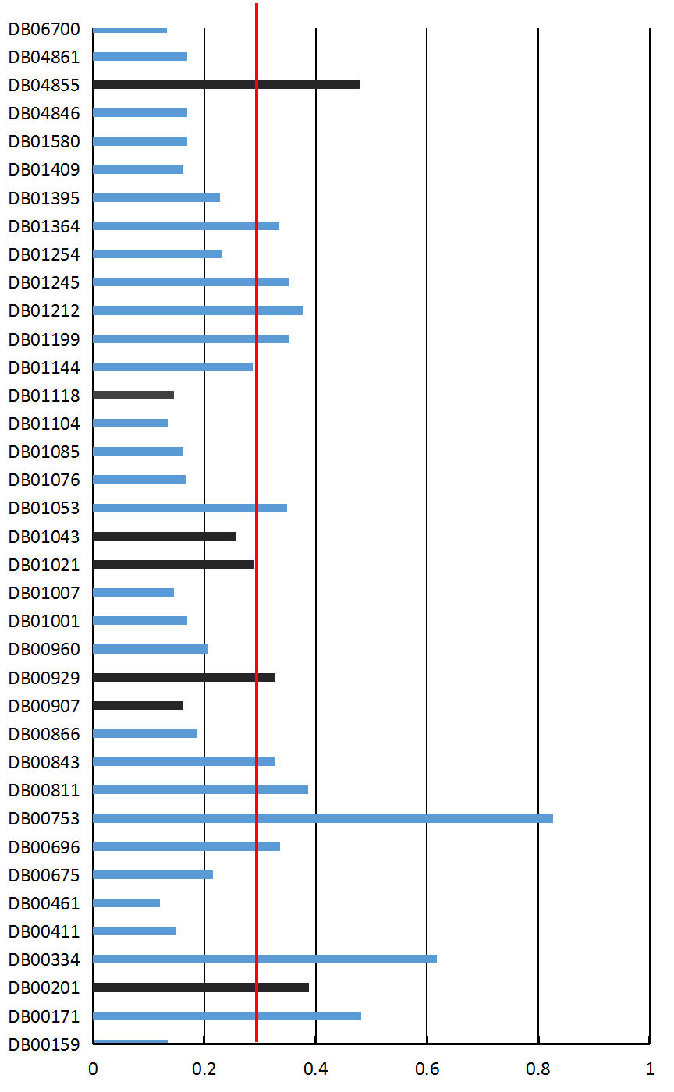

**Table t1:** The Dataset 2 contains 575 drugs, 981 targets and 8008 known drug target interactions. After 5-fold cross validation, the comparison of PPDTS and baseline methods in each evaluation parameter results is shown in the table.

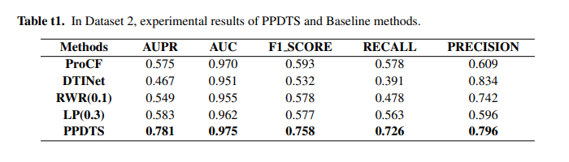

**Table t2:** In order to evaluate the effectiveness of our model, our model is compared with the advanced negative sample selection method proposed by Luo et al. (PMID: 28924171). In the method of Luo et al., the number of negative samples is 10 times that of positive samples. The experimental comparison is as follows. We take 1923 DTIs in the experimental data of Luo et al. As positive samples, including 708 kinds of drugs and 1512 kinds of targets. Then we selected 19230 DTIs from non drug-target interactions as negative samples, and through 5-K cross validation, the experimental results are shown in the table.

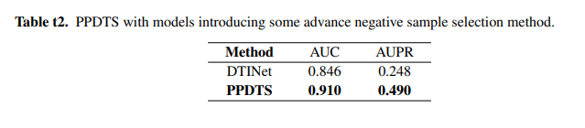  
**Table t3:** To dataset1, PPDTS has predicted 786 potential DTIs. After verified in DrugBank and UniProt databases. There are 7 kinds of DTIs which have been proven by the literature, and have obvious pharmacological effects.

